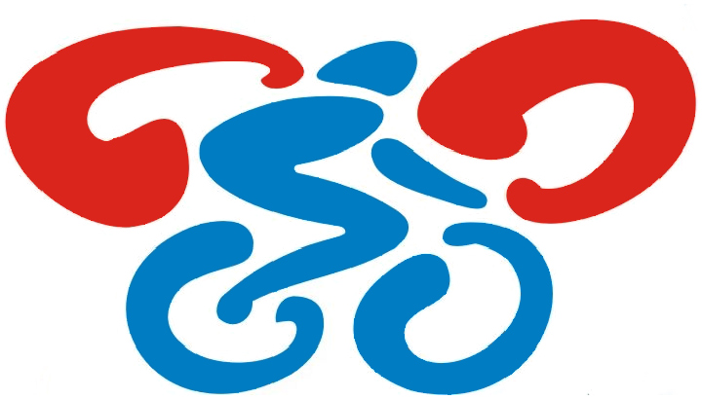

safrata.cyklo@centrum.cz
www. sksafrata.sweb.cz



Město Bohumín

Výsledková listina veřejného MTB závodu půlmaraton, pořádaného jako :

- 3. závod bohumínského MTB seriálu „Lochness Gliňoče 2009“

27.9.2009



 |  |  |  | 40 km
1. |  | 1979 |  | Mindek Tomáš |  | Přátelé Zeleného  údolí |  | masters ml. |  | 1:39:32
2. |  | 1975 |  | Byrtus Ivo |  | SK MADT Sport  Klapka Karviná |  | masters ml. |  | 1:41:45
3. |  | 1989 |  | Kubica Roman |  | SK Jíří team  Ostrava |  | elite |  | 1:43:53
4. |  | 1985 |  | Malošík Jan |  | CK Orlík Orlová |  | elite |  | 1:45:12
5 |  | 1990 |  | Rakušan Vojtěch |  | SK Maxbike  Orlová |  | elite |  | 1:50:06
6. |  | 1976 |  | Huráč Zdenek |  | SK Maxbike  Orlová |  | masters ml. |  | 1:51:30
7. |  | 1963 |  | Konečný Pavel |  | SK Maxbike  Orlová |  | masters ml. |  | 1:51:30
8. |  | 1970 |  | Sýkora Miroslav |  | SK Šafrata  Bohumín |  | masters ml. |  | 1:54:05
9. |  | 1973 |  | Hartig David |  | SK Šafrata  Bohumín |  | masters ml. |  | 1:56:49
10. |  |  |  | Grzempa Grzegorz |  | Start  Bielsko Biala |  | masters st. |  | 2:02:31
11. |  | 1992 |  | Bartošová Denisa |  | SK Maxbike  Orlová |  | juniorka |  | 2:08:38
12. |  | 1944 |  | Homola Petr |  | SK Šafrata  Bohumín |  | masters st. |  | 2:16:30
13. |  | 1961 |  | Neuwirt Stanislav |  | Ostrava |  | masters ml. |  | 2:17:47
14. |  |  |  | Grepl Vincenc |  | SK MADT Sport  Klapka Karviná |  | masters st. |  | 2:33:33
15. |  | 1994 |  | Keisler Jiří |  | SK Šafrata  Bohumín |  | kadet |  | 2:47:52
16. |  | 1969 |  | Součková Patricie |  | CK Orlík Orlová |  | žena |  | 2:50:41
 |  |  |  | Fierla Ondřej |  | CK FESO  Petřvald |  | kadet |  | vzdal
 |  |  |  | Grepl Radim |  | SK MADT Sport  Klapka Karviná |  | elite |  | vzdal

 |  |  |  | 25 km
1. |  | 1995 |  | Wala Jan |  | SK Maxbike Orlová |  | starší žák |  | 1:02:41

 |  |  |  | 15 km
1. |  | 1997 |  | Glogovský Daniel |  | SK Maxbike  Orlová |  | mladší žák |  | 44:00
2. |  | 1997 |  | Depta Martin |  | SK Maxbike  Orlová |  | mladší žák |  | 47:31
3. |  | 1998 |  | Míček Matěj |  | SK Maxbike  Orlová |  | mladší žák |  | 49:42
4. |  | 1997 |  | Marcalík Adam |  | SK Jiří team  Ostrava |  | mladší žák |  | 53:28
5. |  | 1998 |  | Pilchovská Aneta |  | SK Šafrata  Bohumín |  | žákyně |  | 57:01
6. |  | 2002 |  | Huráč Vojtěch |  | SK Maxbike  Orlová |  | předžák |  | 1:00:11

Sepsal : Šafrata Rostislav
ředitel závodu

Pořadí po 3. etapách

 2 0 0 9

Výsledková listina po 3.etapě :
- 1.etapa : 1.5. MTB cena Bohumína
- 2.etapa : 15.8. Australská vylučovací jízda
- 3.etapa : 27.9. Půlmaraton

Hlavní kategorie – žákyně a mladší žáci :
1. |  | Depta Martin |  | SK Maxbike Orlová |  | 10 |  | 5 |  | 24 |  | 39
2. |  | Pilchovská Aneta |  | SK Šafrata Bohumín |  | 4 |  | 4 |  | 14 |  | 22
3. |  | Glogovský Daniel |  | SK Maxbike Orlová |  |  |  | 12 |  | 30 |  | 42
4. |  | Poboźniak Patrik |  | LSK Iskra Glogoczów |  | 15 |  | 15 |  |  |  | 30
5. |  | Bednarzyk Iwona |  | LSK Iskra Glogoczów |  | 12 |  | 8 |  |  |  | 20
6. |  | Míček Matěj |  | SK Maxbike Orlová |  |  |  |  |  | 20 |  | 20
7. |  | Marcalík Adam |  | SK Jiří team Ostrava |  |  |  |  |  | 16 |  | 16
8. |  | Kalus Marek |  | SK Jiří team Ostrava |  | 7 |  | 7 |  |  |  | 14
9. |  | Muś Bartolomiej |  | MTB Silesia Rybnik |  | 3 |  | 10 |  |  |  | 13
10. |  | Mudříková Katka |  | TJ Bohumín - Kolík |  | 8 |  |  |  |  |  | 8
11. |  | Porwolik Jan |  | Bohumín |  | 6 |  |  |  |  |  | 6
 |  | Olivová Alexandra |  | Bike 2000 |  |  |  | 6 |  |  |  | 6
13. |  | Lehocký David |  | SK Maxbike Orlová |  | 5 |  |  |  |  |  | 5
14. |  | Wala Vojtěch |  | SK Maxbike Orlová |  |  |  | 3 |  |  |  | 3

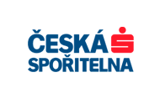

Starší žáci a kadetky :

1. |  | Wala Jan |  | SK Maxbike Orlová |  | 15 |  | 10 |  | 30 |  | 55
2. |  | Skalka Lukasz |  | LKS Iskra Glogoczów |  | 12 |  | 15 |  |  |  | 27
3. |  | Prejda Václav |  | SK Jiří team Ostrava |  |  |  | 12 |  |  |  | 12
4. |  | Glombek Štěpán |  | 3SA UAX Racing team |  | 10 |  |  |  |  |  | 10
5. |  | Hrachovina Eduard |  | Yogi Racing Ostrava |  | 8 |  |  |  |  |  | 8
6. |  | Suder David |  | LKS Iskra Glogoczów |  | 7 |  |  |  |  |  | 7
7. |  | Šafratová Nela |  | SK Šafrata Bohumín |  | 6 |  |  |  |  |  | 6

Kadeti, juniorky a ženy :

1. |  | Bartošová Denisa |  | SK Maxbike Orlová |  | 1 |  | 7 |  | 30 |  | 38
2. |  | Grabski Oskar |  | Bike team Pawlowiczki |  | 15 |  | 12 |  |  |  | 27
3. |  | Keisler Jiří |  | SK Šafrata Bohumín |  | 1 |  |  |  | 24 |  | 25
4. |  | Součková Patricie |  | CK Orlík Orlová |  |  |  |  |  | 20 |  | 20
5. |  | Jakl Tomáš |  | SK Jiří team Ostrava |  | 8 |  | 10 |  |  |  | 18
6. |  | Kožušník Adam |  | SK Maxbike Orlová |  |  |  | 15 |  |  |  | 15
7. |  | Maráčková Pavlína |  | SK Jiří team Ostrava |  | 4 |  | 8 |  |  |  | 12
8. |  | Fierla Ondřej |  | CK Feso Petřvald |  | 12 |  |  |  |  |  | 12
9. |  | Stolarčík Tomáš |  | SK Jiří team Ostrava |  | 10 |  |  |  |  |  | 10
10. |  | Tkocz Anna |  | Progres Rybnik |  | 1 |  | 6 |  |  |  | 7
11. |  | Rodacki Adam |  | MTB Silesia Rybnik |  | 7 |  |  |  |  |  | 7
12. |  | Jurková Soňa |  | TJ Baník Ostrava |  | 6 |  |  |  |  |  | 6
13. |  | Nováková Lucie |  | SK Jiří team Ostrava |  | 5 |  |  |  |  |  | 5
 |  | Stawicki Adam |  | Žory |  |  |  | 5 |  |  |  | 5
15. |  | Vítková Nikola |  | Bike2000 |  |  |  | 4 |  |  |  | 4
16. |  | Lagová Alena |  | SK Šafrata Bohumín |  | 1 |  | 2 |  |  |  | 3
17. |  | Jaklová Lenka |  | ACK Stará Ves |  | 3 |  |  |  |  |  | 3
 |  | Gnojková Katrin |  | SK Šafrata Bohumín |  |  |  | 3 |  |  |  | 3
19. |  | Jalowiecka Darja |  | MTB Silesia Rybnik |  | 2 |  |  |  |  |  | 2
20. |  | Čupová Jana |  | CK Frenštát |  | 1 |  |  |  |  |  | 1
 |  | Polách Martin |  | SK MADT Sport Klapka |  | 1 |  |  |  |  |  | 1
 |  | Sznapka Martin |  | SK MADT Sport Klapka |  | 1 |  |  |  |  |  | 1
 |  | Orzel Dominik |  | Rybnik |  | 1 |  |  |  |  |  | 1
 |  | Pyszková Kristina |  | SK Šafrata Bohumín |  |  |  | 1 |  |  |  | 1

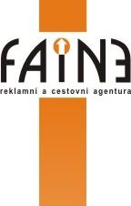
faine@faine.cz
www.faine.cz

Masters mladší :

1. |  | Byrtus Ivo |  | SK MADT Sport Klapka |  | 8 |  | 12 |  | 24 |  | 44
2. |  | Sýkora Miroslav |  | SK Šafrata Bohumín |  | 1 |  | 5 |  | 14 |  | 20
3. |  | Hartig David |  | SK Šafrata Bohumín |  | 1 |  | 4 |  | 12 |  | 17
4. |  | Mindek Tomáš |  | Přátelé Zeleného údolí |  |  |  |  |  | 30 |  | 30
5. |  | Kovařík Ivo |  | SK Jiří team Ostrava |  | 12 |  | 15 |  |  |  | 27
6. |  | Huráč Zdeněk |  | SK Maxbike Orlová |  |  |  |  |  | 20 |  | 20
7. |  | Galuška Tomáš |  | SK Šafrata Bohumín |  | 10 |  | 7 |  |  |  | 17
8. |  | Konečný Pavel |  | SK Maxbike Orlová |  |  |  |  |  | 16 |  | 16
9. |  | Rycombel Lukasz |  | Cycling Sixty Seven |  | 7 |  | 8 |  |  |  | 15
10. |  | Sliź Slawomir |  | Twomark |  | 15 |  |  |  |  |  | 15
11. |  | Kubala Janusz |  | SK MADT Sport Klapka |  |  |  | 10 |  |  |  | 10
 |  | Neuwirt Stanislav |  | Ostrava |  |  |  |  |  | 10 |  | 10
13. |  | Řepecký Tomáš |  | Vortex Bike team |  | 6 |  |  |  |  |  | 6
 |  | Ištván Antonín |  | KCK Zlín |  |  |  | 6 |  |  |  | 6
15. |  | Šíma Martin |  | Max Cursor |  | 5 |  |  |  |  |  | 5
16. |  | Piotrowski Andrzej |  | GT Airco team |  | 4 |  |  |  |  |  | 4
17. |  | Fierla Jan |  | CK Feso Petřvald |  | 3 |  |  |  |  |  | 3
 |  | Fajkus Martin |  | SK Šafrata Bohumín |  |  |  | 3 |  |  |  | 3
19. |  | Gajdzik Piotr |  | Mikolów |  | 2 |  |  |  |  |  | 2
20. |  | Hrachovina Rostislav |  | Yogi Racing Ostrava |  | 1 |  |  |  |  |  | 1
 |  | Tureček Martin |  | SK MADT Sport Klapka |  | 1 |  |  |  |  |  | 1

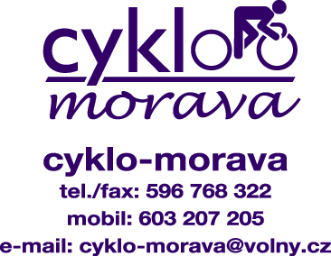

Masters starší :

1. |  | Grzempa Grzegorz |  | Start Bielsko Biala |  | 8 |  | 10 |  | 30 |  | 48
2. |  | Sedláček Jiří |  | SK Jiří team Ostrava |  | 15 |  | 15 |  |  |  | 30
3. |  | Grepl Vincenc |  | SK MADT Sport Klapka |  | 6 |  |  |  | 20 |  | 26
4. |  | Homola Petr |  | SK Šafrata Bohumín |  |  |  |  |  | 24 |  | 24
5. |  | Sikora Petr |  | SK Šafrata Bohumín |  | 10 |  | 12 |  |  |  | 22
6. |  | Domźalski Zbigniew |  | Tigris Berkner |  | 5 |  | 8 |  |  |  | 13
7. |  | Baier Jan |  | SK Šafrata Bohumín |  | 12 |  |  |  |  |  | 12
8. |  | Kuczera Tadeusz |  | Jankowice |  | 7 |  |  |  |  |  | 7

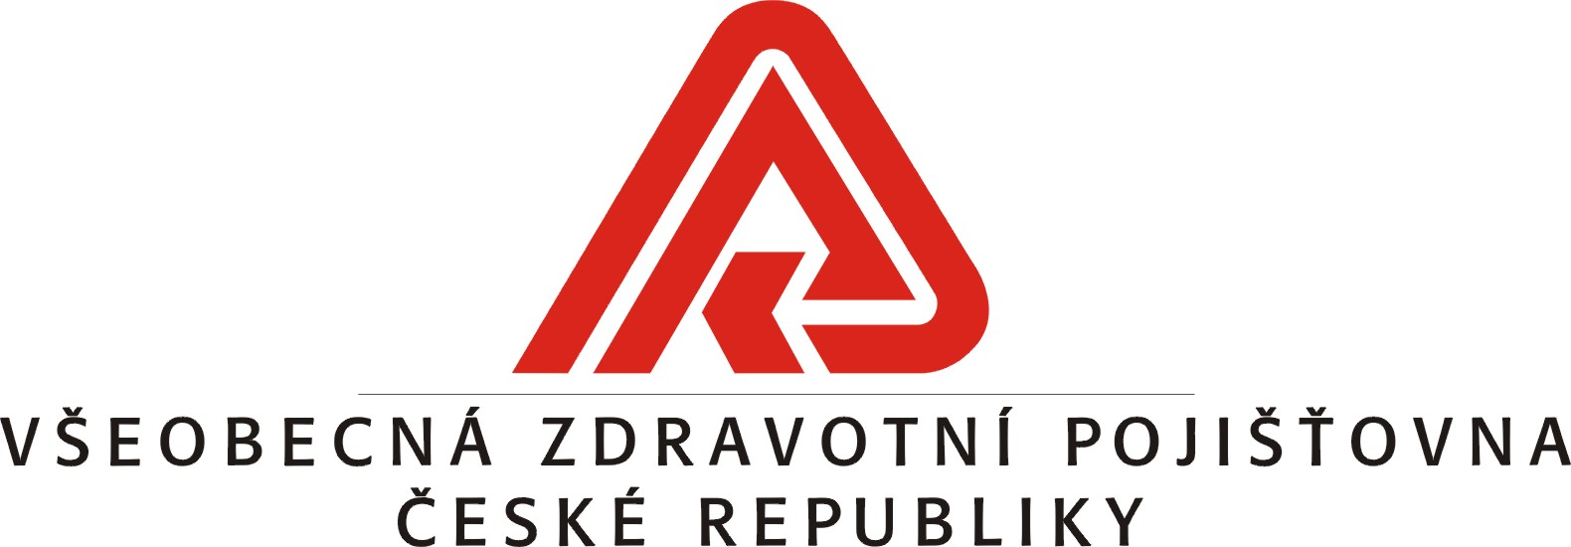

Muži a junioři :

1. |  | Rakušan Vojtěch |  | SK Maxbike Orlová |  |  |  | 12 |  | 20 |  | 32
2. |  | Kubica Roman |  | SK Jiří team Ostrava |  |  |  |  |  | 30 |  | 30
3. |  | Malošík Jan |  | CK Orlík Orlová |  |  |  |  |  | 24 |  | 24
4. |  | Mazij Lukasz |  | Rowery Jumar |  | 12 |  | 10 |  |  |  | 22
5. |  | Bajerski Michal |  | Start Bielsko Biala |  | 10 |  | 7 |  |  |  | 17
6. |  | Bartkowiak Pawel |  | MTB Silesia Rybnik |  | 15 |  |  |  |  |  | 15
 |  | Droždž Tomasz |  | Polsko |  |  |  | 15 |  |  |  | 15
8. |  | Furczyk Maciej |  | Start Bielsko Biala |  |  |  | 8 |  |  |  | 8
 |  | Kwaskiewicz Konrad |  | AZS AWF Katowice |  | 8 |  |  |  |  |  | 8
10. |  | Sedláček Marek |  | SK Jiří team Ostrava |  | 7 |  |  |  |  |  | 7
11. |  | Beneš Jiří |  | SK Jiří team Ostrava |  |  |  | 6 |  |  |  | 6
 |  | Sigmund Martin |  | CK Frenštát |  | 6 |  |  |  |  |  | 6
13. |  | Hanusek Tomáš |  | SK MADT Sport Klapka |  | 5 |  |  |  |  |  | 5
 |  | Borszický Denis |  | CK Orlík Orlová |  |  |  | 5 |  |  |  | 5
15. |  | Grepl Radim |  | SK MADT Sport Klapka |  | 4 |  |  |  |  |  | 4
16. |  | Klos Viktor |  | SK Jiří team Ostrava |  | 3 |  |  |  |  |  | 3
17. |  | Nowak Rafal |  | Rydultowy |  | 2 |  |  |  |  |  | 2
18. |  | Ryšavý Tomáš |  | SK Maxbike Orlová |  | 1 |  |  |  |  |  | 1

V roce 2010 bude hlavní soutěží kategorie masters mladší !

